# Footplant

|  |  |
| --- | --- |
|  |  |

## Max External Rotation

## Ball Release

|  |  |
| --- | --- |
|  |  |

# Kinematics Report

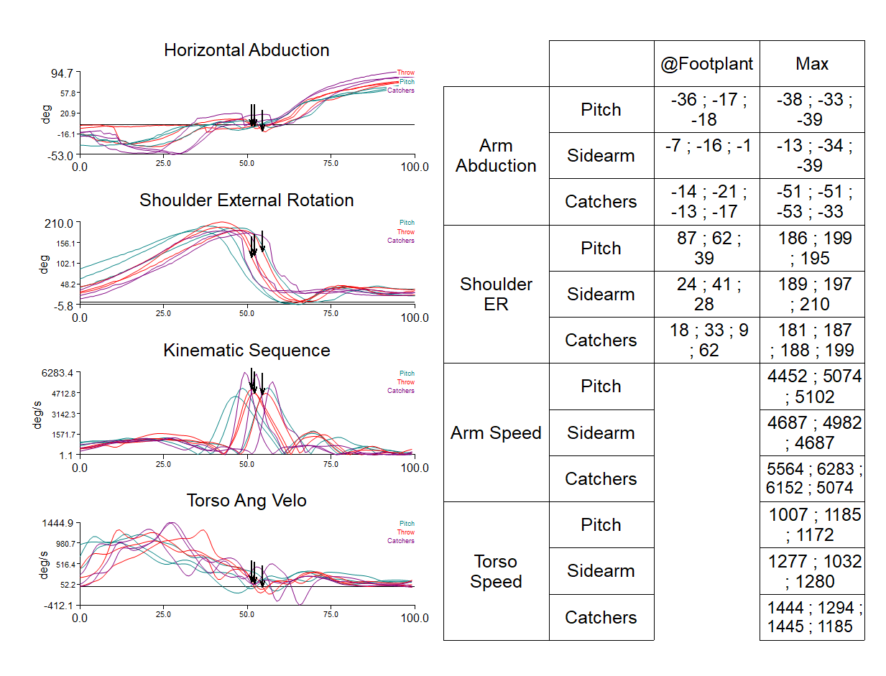

# Athletic Screen Report

